HOW TO BE “SOCIAL”
Using Social Media to Help Increase Awareness of Adoption Events

Using social media to help promote your event can do a lot to spread awareness for your participation in Iams Home 4 the Holidays, in addition to the traditional media outreach that you conduct. This document provides an overview of top social media platforms, as well as tips to help you better understand how social media can assist you in your efforts and generate awareness.

After determining the best type of event for your facility, consider the tips below to enhance your planned activities even further. The following descriptions provide an overview of each type of social media platform and will help you determine what’s best for you and your team.

The social media platforms included in this document are:
- Facebook
- Twitter (micro-blogging)
- YouTube
- Blogs

Please note that different social media platforms have different terms of use and privacy policies. You are responsible for your use of these social media platforms.



Overview:
Facebook is a social media hub designed to foster long-term relationships and currently has more than 900 million active users worldwide. One of the biggest benefits of this platform is how quickly and easily it allows you to spread information and content.

Facebook Account Types:
Facebook Page: Designed principally for companies, organizations, causes and people. By creating a Facebook Page, you can choose to “Like” your animal organization, post to your public wall, send messages, share photos and more. In turn, you can share information and photos via your wall and send messages to one or all of the people who “like” your facility.

Iams Home 4 the Holidays Connection: Creating a Facebook Page can be a great way to connect with fans as well as potential adopters to spread the message about your efforts.

Benefits Include:
- Ability to build anticipation for your adoption center to the planned Iams Home 4 the Holidays event
- Build awareness before, during and after your event
- Provide a forum for people to discuss your center, the animals available for adoption at your event, successes to-date, etc.
- Encourage people to post images of pets they’ve already adopted at events taken place at your location
- Keep fans regularly updated about how many adoptions have taken place to date from the event
- Geo targeting in is the method of determining the geolocation of the community fans and delivering tailored content and information relevant to them based on his/her location, such as region/state, city or metro code/ZIP code.

Key Items to Remember:
- Update frequently (at least three times per week)
- Make it as visual as possible
- Follow-up with those who post photos or leave comments
- Ask questions that solicit interaction associated with your pet adoption event (“Do you own a pet?” or “Would you consider adopting a dog or cat?”)

How to Set Up Your Facebook Page:
To easily create an account, visit www.Facebook.com and enter your information (first and last name, email address and a password for your account).

Once the account is created, you can establish a Facebook page quickly and easily. For information on how to create your page visit: How to Create a Facebook Page

By using your personal Facebook account to connect with friends and family, you can encourage them to join your page – helping to spread the word and build a fan base! Additionally, encourage staff at your location to join your Facebook community and help the word spread virally through their connections.

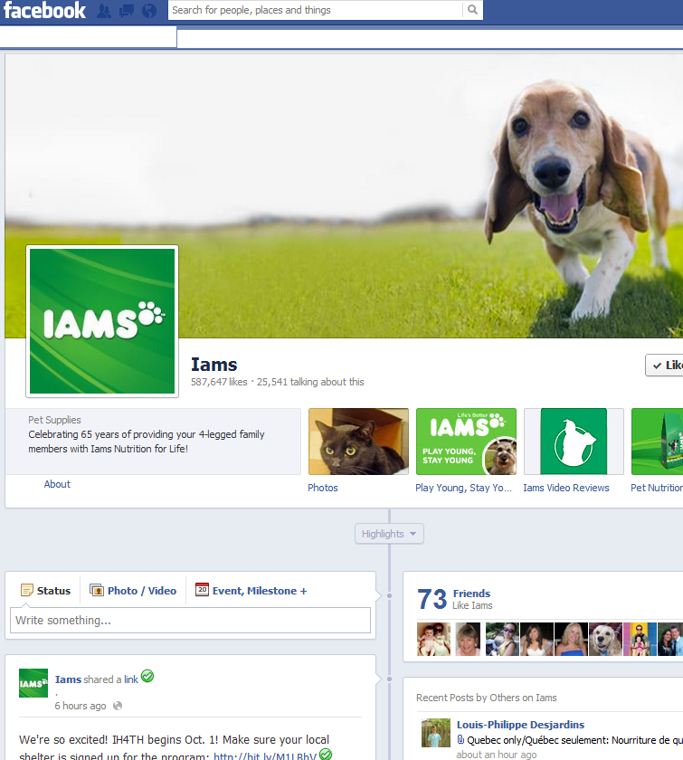


Overview:
A free social networking and micro-blogging web-based service designed for one-on-one conversations, it allows users to send and receive “tweets.” By signing up for Twitter, you can connect with new and old colleagues by “following” them. Information is shared via 140-character updates with your followers.

Benefits of Twitter:
Twitter is a great platform to meet new people and share information. Given the length of each tweet, 140 characters, information is easily shared and re-shared. This is a great way to spread your adoption messages and help rally people to support your event. You can also search out like-minded people on Twitter and “follow” them, often raising awareness for your adoption center and event when they look to see whether they want to “follow” you back.

Setting Up an Account:
- Visit www.Twitter.com and click on “Get Started—Join!” Follow the steps to set up your account
- Search Twitter (http://www.search.twitter.com) for key words such as “dog” or “cat” or “pet adoption” to find people who are talking about it. Follow everyone who you find interesting
- Begin tweeting. Talk about you, your organization, Iams Home 4 the Holidays, your cause, adoption totals, available animals and anything people might find interesting
- Be sure to interact with those who interact with you
- Tweet often (at least one tweet per day and respond to direct messages within one day)

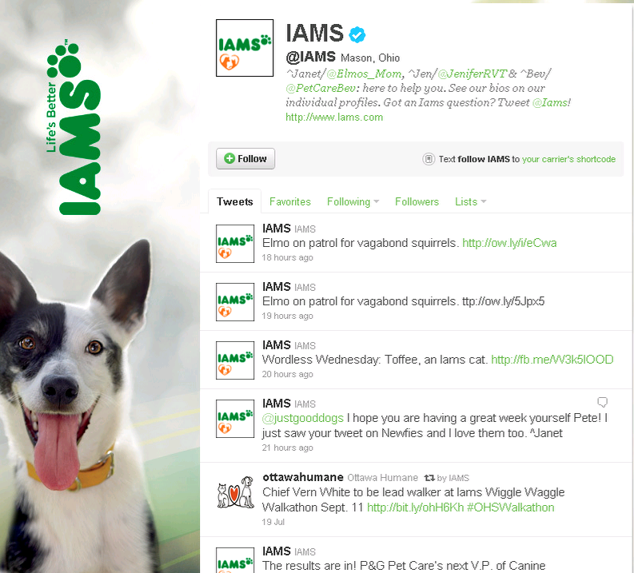

For more detailed information, please review: The Twitter Guidebook



Overview:
YouTube is a video-sharing website where users can upload, view and share videos to an audience of millions around the world. Content includes a wide variety of user-generated videos as well as videos created by media corporations and other organizations.

Benefits of YouTube:
YouTube is designed to educate, engage and entertain. It is easy to share and post on other social networks such as YouTube and Twitter. It also brings offline events online such as behind-the-scenes video content. This is a great way to spread your adoption messages and help rally people to support your event.

Setting Up an Account:
- Visit www.youtube.com and click on “Sign In” on the top right corner of the page. Follow the steps to set up your account and create your own YouTube channel
- Start by uploading videos like adoption events or behind-the-scenes fun footage of your organization
- Begin sharing by linking videos to other social networks such as Facebook and Twitter
- Be sure to interact with those who interact with you on your video responses feed
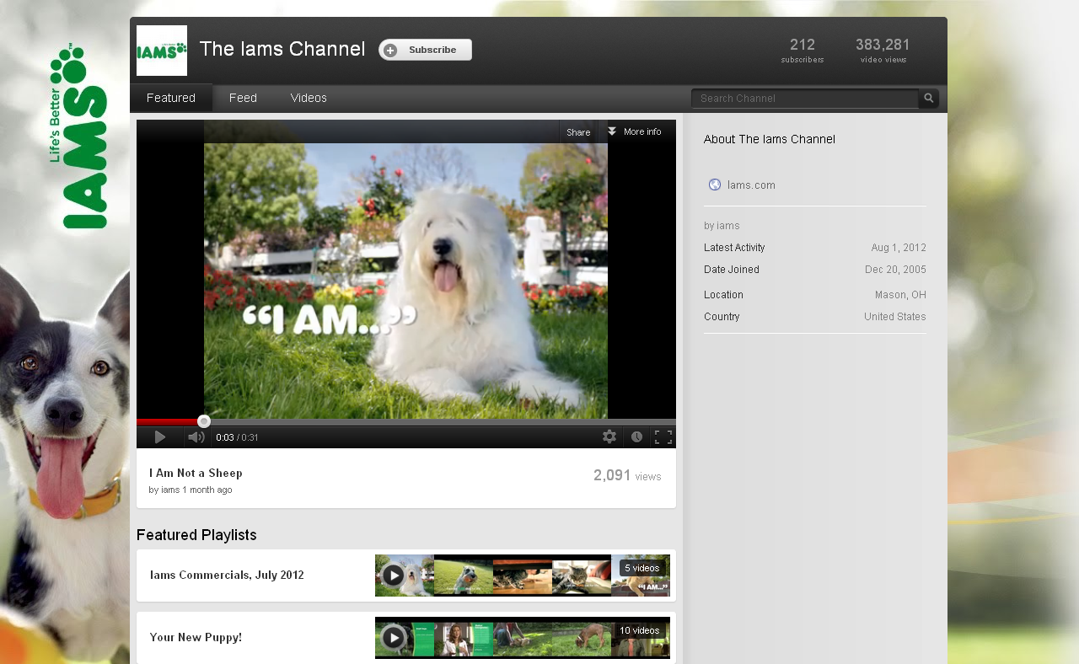


Blog (Web log)
A type of website that is maintained by an individual (or a company or organization), through a series of entries that include regular updates, commentary, descriptions of events as well as photographs and videos. Blogs can range from personal diaries to commentary or news on a particular subject.

To promote your participation in Iams Home 4 the Holidays, you can either build a blog or utilize existing blogs to gain coverage.

Building a Blog
Select a platform (Blogspot, Typepad, WordPress, etc.) and follow the steps to set up your blog. You will be asked to select a blog name, a URL, write a bio and even post your first entry. Once your blog is up and running, be sure to update it often (at least three times a week) and post as much information and as many images as possible.

Conducting Blog Outreach
While building a blog can be very time intensive, tapping into the network that other bloggers have built can be a great way to spread your message. Introducing yourself and sharing your message with other bloggers is a great way to spread information about Iams Home 4 the Holidays and your involvement.

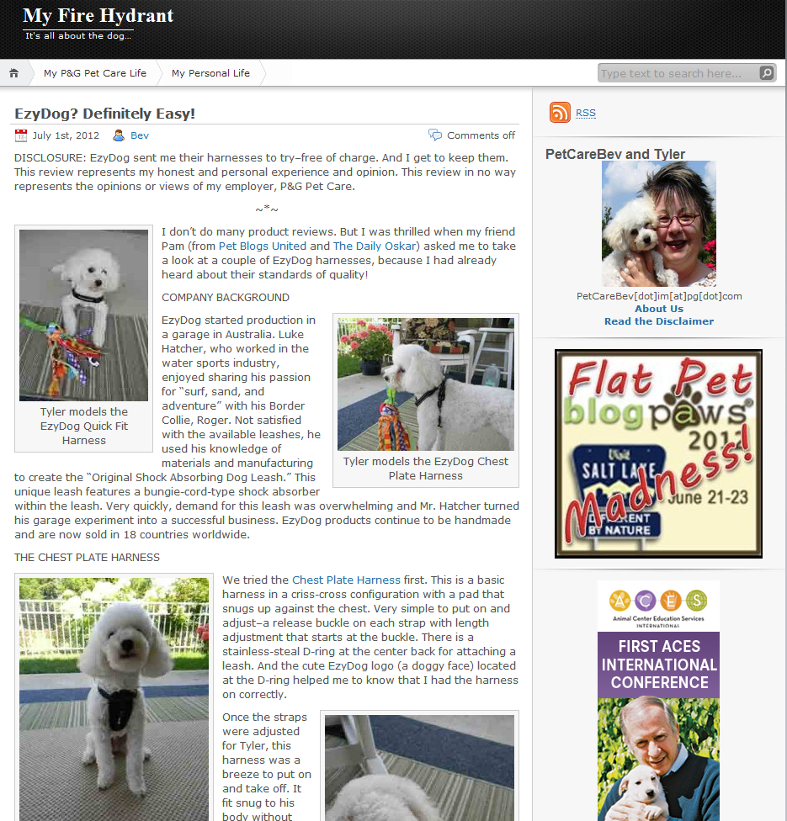

Step 1: Initial Communication – Initial Outreach to Pet Lovers Websites/Blogs

Below is a sample email to customize and share with bloggers. Feel free to customize it based on the blogger or website you are targeting for connection with your organization’s efforts.

Hi (Name),

I hope this email finds you well. My name is (name), and I’m with (organization), (short description) in (your city). We’ve created an event that involves one of the world’s most successful pet adoption drives, Iams Home 4 the Holidays. This year, we’re focused on getting more pets adopted and providing our animal shelter partners with Iams food so dogs and cats awaiting their new home have the best nutrition possible.

Today, thousands of pet adoption centers and rescue organizations from around the world participate in the program and working together, more than 7 million pets have been adopted since it began in 1999. Last year alone, more 1.2 million animals were adopted – that’s nine adoptions per minute! With the help from animal lovers like you, we can work together to continue making a difference.

We'd appreciate your help sharing information about our event (include event details – timing, location, etc.) with your readers. I am also happy to put you in touch with (insert spokesperson) who can talk with you about the event happenings.

To help you spread the word, we’ve created a variety of fun, interactive online assets you can share with your readers. Please contact Chad Darwin at chad.darwin@citizenrelations.com or 213-996-3776 for more information.

Please let me know if you’d like to be involved in helping spread the word about Iams Home 4 the Holidays, and thank you so much for your consideration and time. We’re happy to share additional information and images of the adoptable pets that we have available.

Best,
(Your name)
(Your email)

Key Online Resources

Iams Home 4 the Holidays:

Facebook
http://www.facebook.com/iams

Twitter
http://www.Twitter.com/iams

Helen Woodward Animal Center:

Facebook Page
http://www.facebook.com/helenwoodwardanimalcenter

Twitter
http://www.twitter.com/HWAC

Search Resources

Google Blog Search
http://blogsearch.google.com

How to Find the ‘Best in Blogs’
http://blogs.com

Blog Search Engine
http://www.blogsearchengine.com

Technorati Search
http://technorati.com/search

Twitter Search
http://www.search.twitter.com

